MORTARVERSE × OUR NORTH STAR

Digital asset brainstorm + first-draft designs
LinkedIn · Instagram · Facebook | Draft for MORTAR review | Sept 18, 2026

The big idea
Our North Star is the destination. The MORTARVERSE is how you get around it. The conference already brands itself with a guiding star, gold sparkles and "Destination: Cincinnati." The app already uses a starfield, planets and "where to go." The collab line writes itself: Follow the North Star… into the MORTARVERSE.
Every asset uses the same move: the conference’s textured blue sky tears open (torn-paper edge, a nod to the curriculum’s collage texture) into the app’s black space, with the four app planets as recurring characters.

Visual system
- Conference side: Blue #3E6BB5 + MORTAR blue texture, gold #F2B632 four-point stars, Eksell Display serif (MORTAR brand font)
- App side: Black space + starfield, red glow #E41A28 / #C1121F, Archivo Black wordmark and Poppins UI type (both from the app), glass cards
- Characters: The four real planet images from the app: Conference Center (cream), Networking Hall (red), The Commons (Saturn), Digital Curriculum (moon)
- Labels: Maison Neue Mono, spaced out and uppercase, for "transmission" / mission-control text

Assets, mapped to the v2 posting calendar
Every post goes out from both the MORTAR and Found House accounts. The captions below are starting points: LinkedIn runs longer and more professional, Instagram shorter and higher-energy, Facebook plain and link-forward.

1 · Launch hero — "Follow the North Star… into the MORTARVERSE"
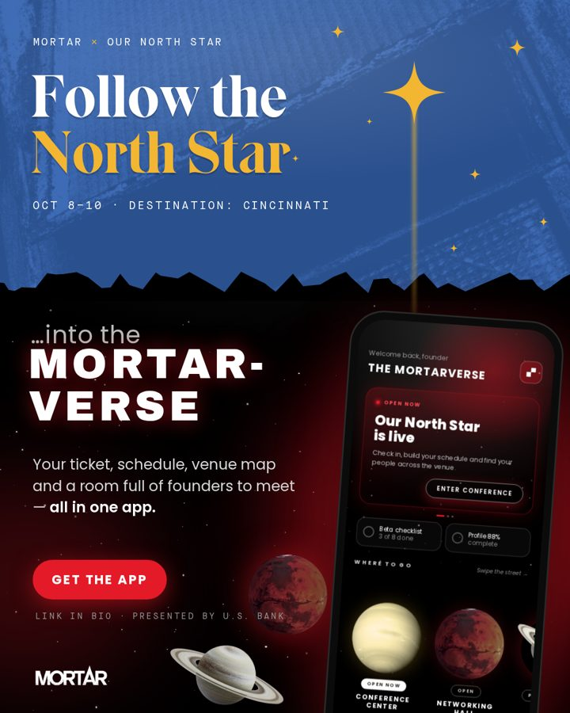
Spec: 1080×1350 (4:5 feed) · IG, FB, LinkedIn
When: Sep 23 (Meet the MORTARVERSE) or as the pinned post
Idea: The North Star’s beam drops through a torn-paper edge from the conference’s blue sky into the Mortarverse’s black space and lands on the phone. The whole collab in one picture: the conference is the destination, the app is how you get around it.
LinkedIn | Our North Star is Oct 8–10 in Cincinnati, and the whole experience runs through the MORTARVERSE app: your ticket, your schedule, the venue map, and a room full of founders to meet. Download it before you land. #OurNorthStar #MORTAR #Cincinnati #Entrepreneurship
Instagram | Follow the North Star ✦ into the MORTARVERSE. Tickets, schedule, venue map and your people, all in one app. Link in bio. #OurNorthStar #MORTARVERSE
Facebook | Headed to Our North Star? Get the MORTARVERSE app first. Your ticket, schedule and networking live there. Oct 8–10, Cincinnati. [link]

2 · "Meet the MORTARVERSE" carousel (5 slides)
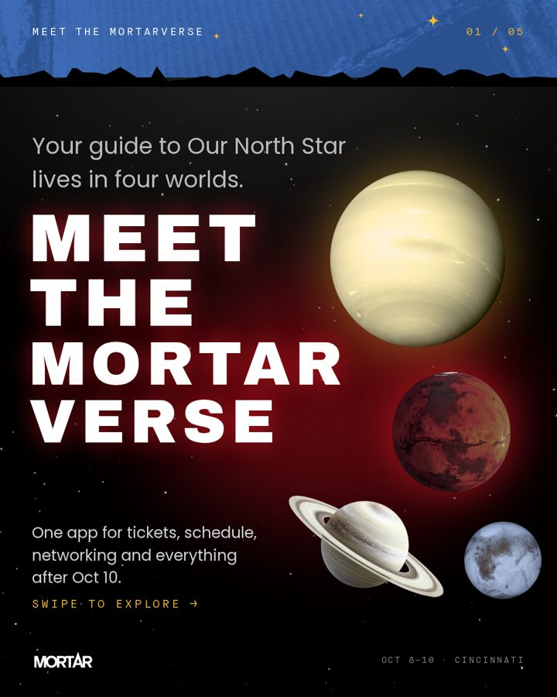
Spec: 1080×1350 × 5 · IG + LinkedIn document/carousel, FB multi-image
When: Sep 23 (matches your v2 "Meet the MORTARVERSE" slot)
Idea: One planet per slide, taken straight from the app’s chooser: Conference Center (cream) → Networking Hall (red) → The Commons (Saturn) → Digital Curriculum (moon) + CTA. Feature copy comes from the app’s own tutorial text, so every claim matches what the app does.
LinkedIn | Meet the MORTARVERSE: four worlds, one app. 🪐 Conference Center opens live during Our North Star. 🔴 Networking Hall is where MORTAR alumni match and message. 🪐 The Commons holds your profile, badges and member card. 🌕 Digital Curriculum is where future alumni start. Swipe through ↓
Instagram | 4 planets. 1 app. Swipe to meet the MORTARVERSE before Our North Star ✦ Which one are you landing on first? 👇
Facebook | Swipe through the four worlds of the MORTARVERSE, the app that powers Our North Star.
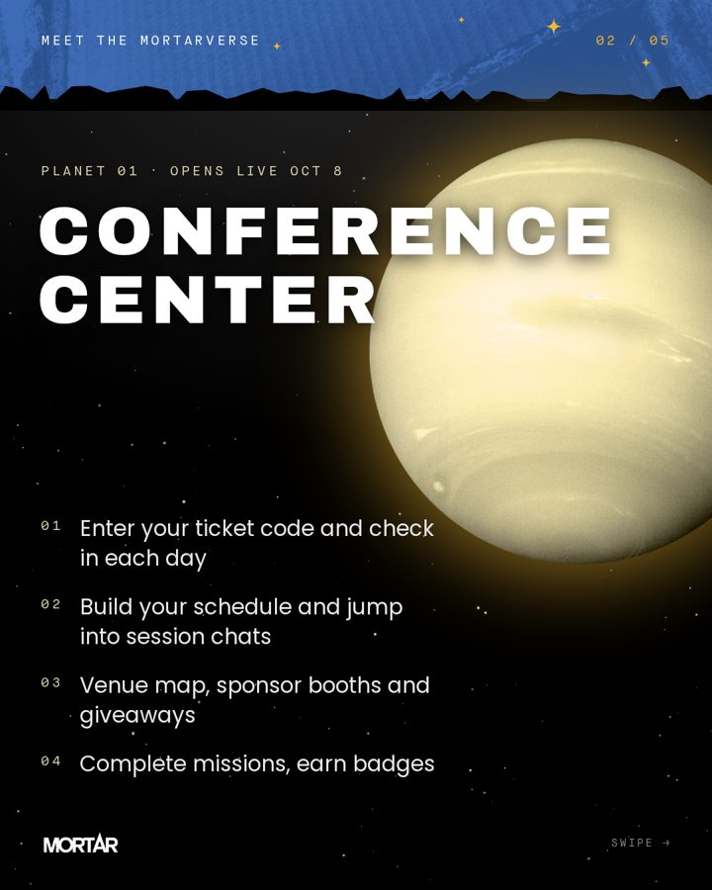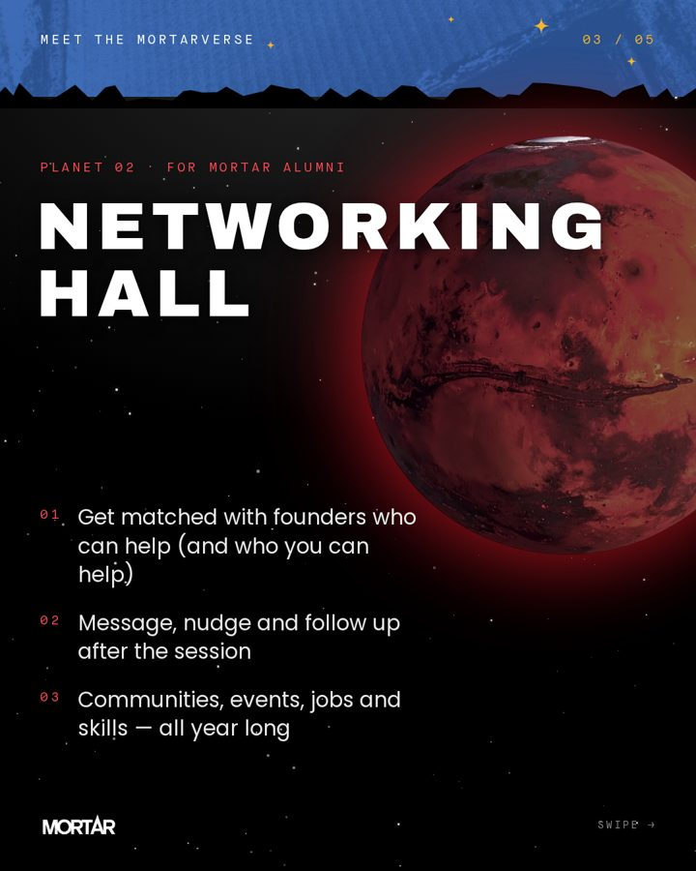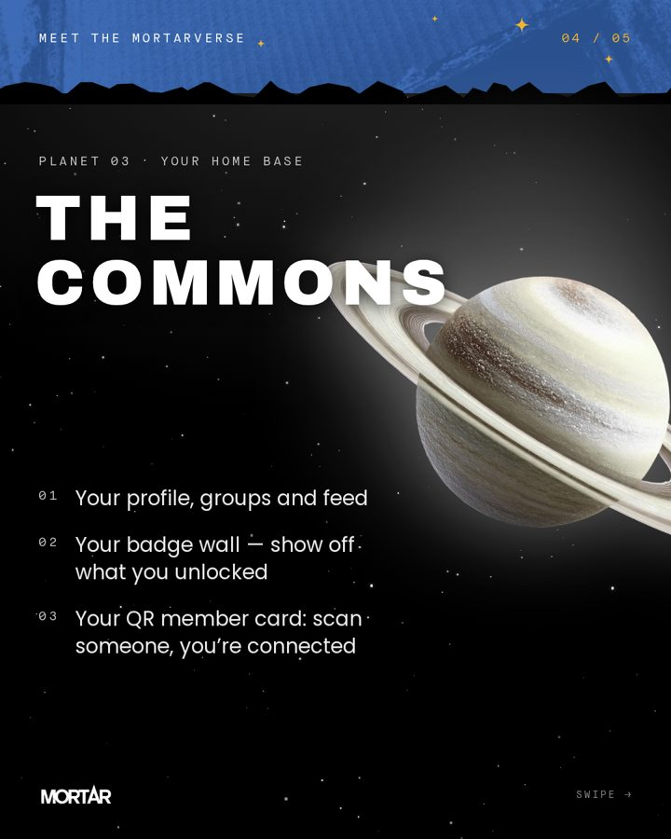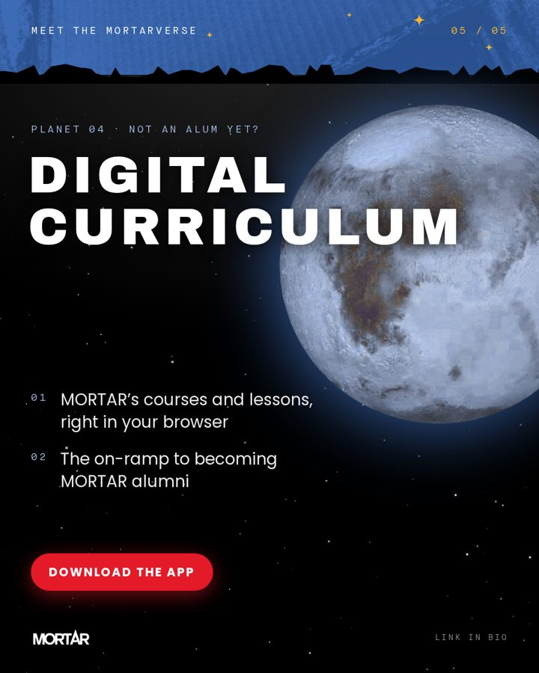

3 · Beta crew recruitment — "CREW WANTED"
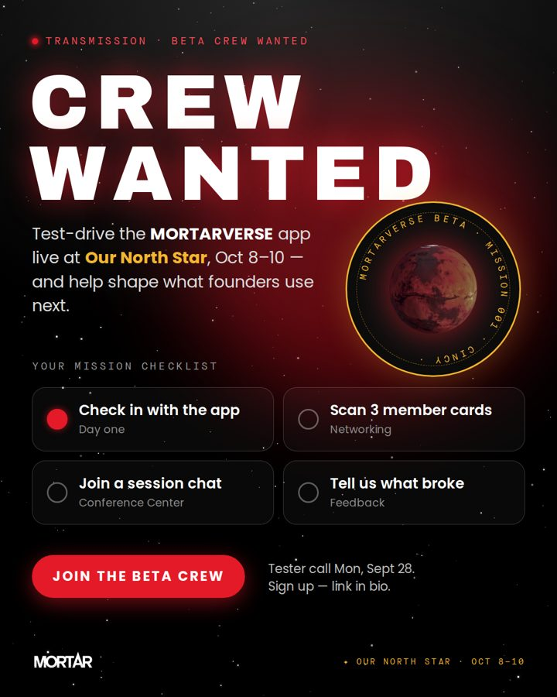
Spec: 1080×1350 · all three
When: Sep 28 (tester call) + Oct 1 (conference + beta testers)
Idea: Recruitment framed as a space mission, with a mission patch. The checklist mirrors the real in-app beta checklist, which ticks itself off as people use the app.
LinkedIn | We’re looking for a beta crew. Test the MORTARVERSE app live at Our North Star, Oct 8–10, and help shape the tools founders use next. Tester call is Mon, Sept 28. Comment "CREW" or use the link to sign up.
Instagram | CREW WANTED 🚀 Test-drive the MORTARVERSE live at Our North Star. Check in, scan cards, join session chats, tell us what broke. Sign up at the link in bio.
Facebook | Want to help build the MORTARVERSE? Join our beta crew at Our North Star. Tester call Mon, Sept 28. Sign up: [link]

4 · Speaker × app series — "Don’t miss it. Save it."
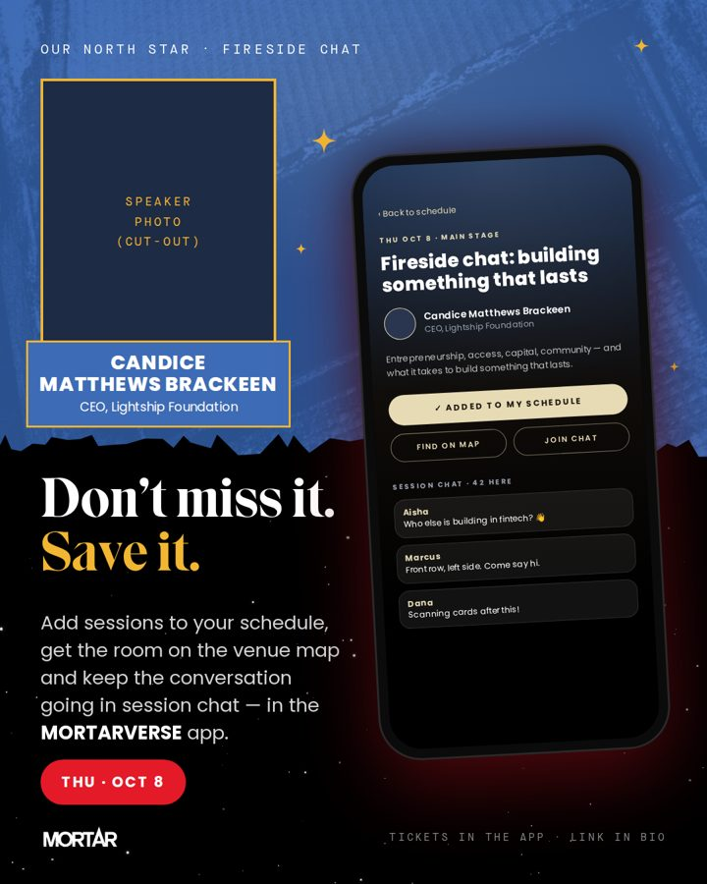
Spec: 1080×1350 · all three
When: Weekly through Oct 7, one per keynote (Candice Oct 8, Felecia Oct 9, …)
Idea: Pairs MORTAR’s existing blue/gold speaker card with a phone showing that session in the app (Add to my schedule · Find on map · Join chat). It builds on the speaker posts MORTAR is already running and turns each one into an app download prompt.
LinkedIn | On Oct 8, Candice Matthews Brackeen joins us for a fireside chat at Our North Star. Add it to your schedule in the MORTARVERSE app, find the room on the venue map and join the session chat. #OurNorthStar
Instagram | Don’t miss it. Save it. ✦ Candice Matthews Brackeen, Thu Oct 8. Add it to your schedule in the MORTARVERSE app (link in bio).
Facebook | Save the session: Candice Matthews Brackeen, Thu Oct 8, Our North Star. Plan your days in the MORTARVERSE app.

5 · Story countdown — "T-MINUS 7 DAYS"
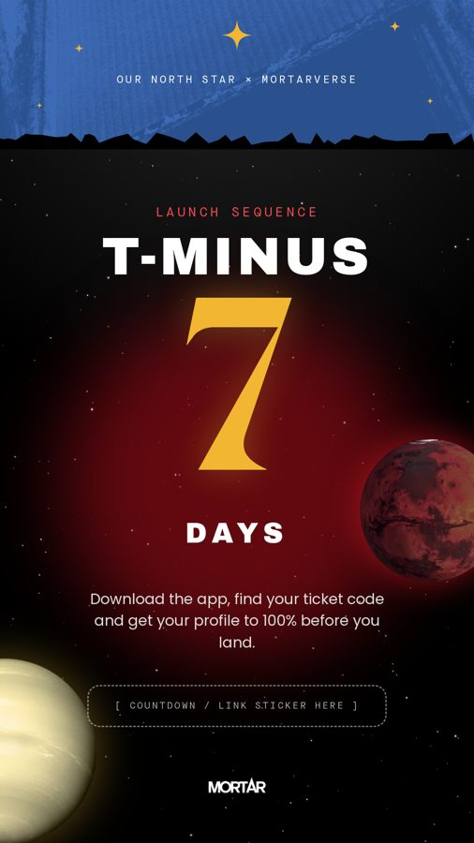
Spec: 1080×1920 · IG/FB Stories (LinkedIn: post as a vertical image)
When: Oct 1 → Oct 7 (swap the number daily; pairs with the Oct 7 day-away TikTok)
Idea: A launch-sequence countdown. The empty slot is for IG’s native countdown or link sticker, so followers get a reminder when doors open.
LinkedIn | (Stories only)
Instagram | Use the countdown sticker named "Our North Star" and the link sticker → app download.
Facebook | Same as IG.

6 · Day-of — "SCAN TO CONNECT"
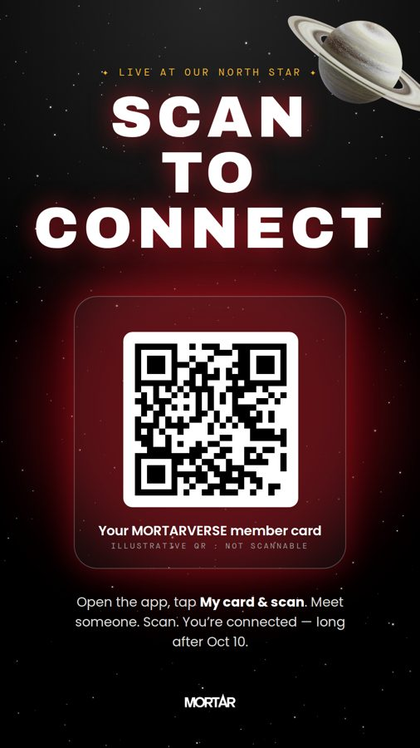
Spec: 1080×1920 · Stories; also prints as a venue sign
When: Oct 8–10 (Day one interviews, Oct 9)
Idea: Teaches people the most useful move at the event: open My card & scan and scan someone’s QR. The QR is illustrative and not scannable. For signage, swap in a real download QR.
LinkedIn | Live from Our North Star: scan to connect. Every attendee has a QR member card in the MORTARVERSE app.
Instagram | Meet someone ➜ scan them ➜ you’re connected ✦ Open the app and tap My card & scan.
Facebook | At Our North Star? Open the MORTARVERSE app and tap My card & scan to connect with people you meet.

7 · LinkedIn profile banner — "TESTING THE MORTARVERSE"
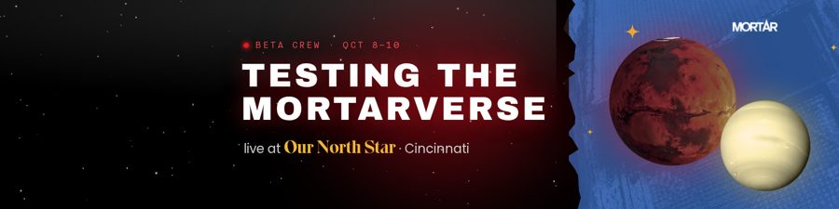
Spec: 1584×396 · personal LinkedIn banners
When: Now through Oct 13 (Shannon, Tianna, Tim, Sean, Grace + any beta crew)
Idea: Free reach from every tester’s profile. The left third stays empty so the profile photo doesn’t cover any text.
LinkedIn | Swap in as your LinkedIn banner and add "Beta crew, MORTARVERSE @ Our North Star" to your headline.
Instagram | n/a
Facebook | Can double as a Facebook profile cover (it will crop slightly).

8 · Event cover — "Our North Star, powered by the MORTARVERSE"
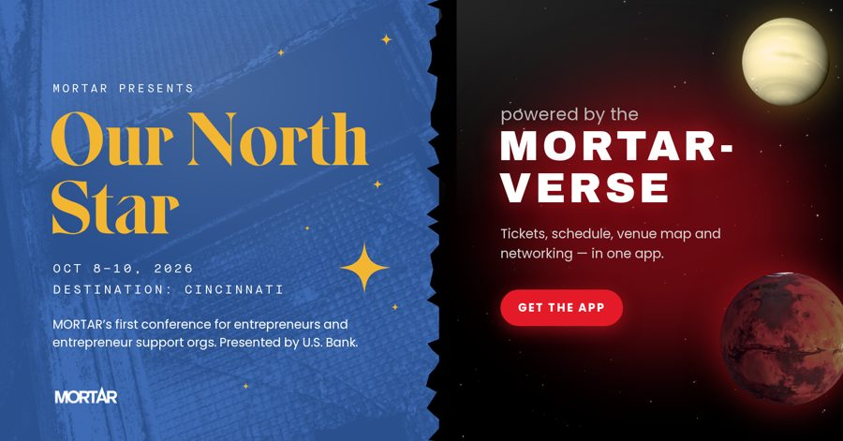
Spec: 1920×1005 · Facebook Event cover; crop for LinkedIn Event (1776×444) or an email header
When: Now
Idea: Conference on the left, app on the right, split by the torn edge. Works as the Facebook/LinkedIn Event cover and as the header for the Oct 7 conference-flyer email.
LinkedIn | Use as the LinkedIn Event cover.
Instagram | n/a
Facebook | Use as the Facebook Event cover.

9 · Recap template — "WHAT WE BUILT IN 3 DAYS"
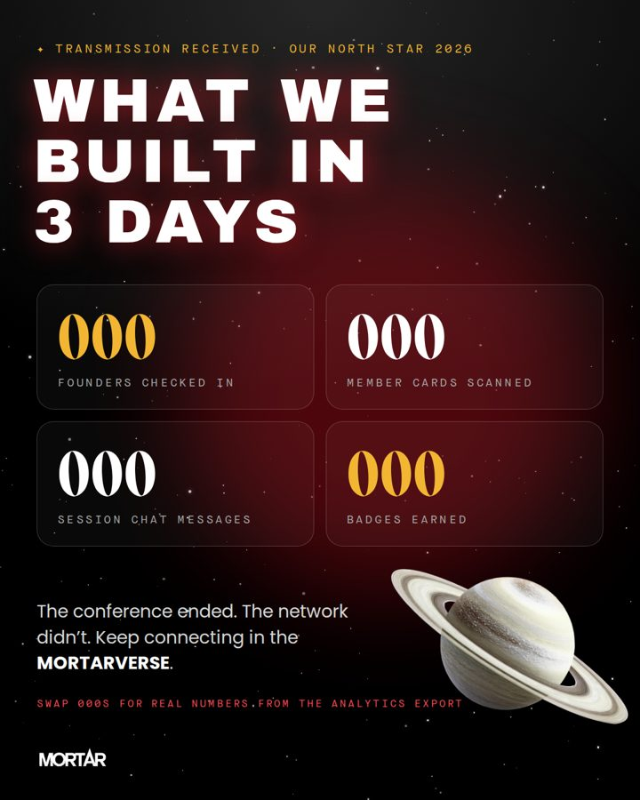
Spec: 1080×1350 · all three
When: Oct 13 (recap montage)
Idea: "Transmission received" stat card. Fill the 000s from the app’s analytics export (check-ins, cards scanned, chat messages, badges). The closing line pushes people to keep using the app after the conference.
LinkedIn | Three days, [000] founders, [000] new connections. The conference ended; the network didn’t. Keep connecting in the MORTARVERSE.
Instagram | Transmission received ✦ Here’s what we built in 3 days at Our North Star.
Facebook | Thank you, Cincinnati. Here’s Our North Star by the numbers.

More ideas to build next
- "Which planet are you?" poll: IG Story quiz or LinkedIn poll: builder (Conference Center), connector (Networking Hall), community (Commons), learner (Digital Curriculum). Easy engagement and it teaches the app’s map.
- Badge share cards: When someone completes a mission or earns a badge, give them a shareable 1080×1920 "Mission complete" card to post and tag @MORTAR. Could become an in-app share button later.
- Lyric transmissions: From the app’s original vibe notes: short hip-hop-inspired lines about grind, legacy, wealth and wellness as floating "transmissions" on a starfield. Write original lines or clear any quotes first.
- Beta crew intros: Headshots of Shannon, Tianna, Tim, Sean and Grace from social media day in the mission-patch frame: "Meet your crew."
- Sponsor orbit: A thank-you post for U.S. Bank using the same system, e.g. "Presented by U.S. Bank." Needs their brand approval.
- Reels/TikTok overlay kit: Transparent PNG versions of the torn edge, stars, planets and the "OPEN NOW" pill to drop over the "9 to 5" and "I’m off that lala" videos so the video content matches the static posts.
- Email pieces: Crop the event cover (8) for the Oct 7 conference-flyer email header, and the Crew Wanted post (3) for the Sep 28 "Calling all beta testers" email.

Before anything posts
- Swap the typed "Our North Star" text for the official Our North Star logo lockup (I didn’t copy the logo from their posts).
- Drop in real speaker photos (cut-outs) for asset 4 and confirm session titles and rooms. "Building something that lasts" is a placeholder taken from the post copy.
- Replace the illustrative QR in asset 6 with a real App Store / Play Store download link or QR for signage.
- Confirm the app store links and the ticket link that "link in bio" points to.
- Confirm with MORTAR that "Networking Hall = for MORTAR alumni" is the right public framing (in the app it shows LOCKED without Expansion access).
- The chat messages and names in the phone mockups (Aisha, Marcus, Dana) are made up. Keep them clearly generic or replace them with beta-crew names who agree to it.
- Add alt text on every post, e.g. "Illustration: a gold star’s beam falls from a blue sky into a black starfield onto a phone showing the MORTARVERSE app."

